**INDEX**

|  |  |  |
| --- | --- | --- |
| **Sr. No.** | **Contents** | **Pg. No.** |
| 1 | Preface | 3 |
| 2 | Acknowledgement | 4 |
| 3 | Project Profile | 5 |
| 4 | Purpose | 6 |
| 5 | Vision & Scope, Features, & Limitations | 7 |
| 6 | Introduction to Development Tools | 10 |
| 7 | Hardware & Software Requirements | 12 |
| 8 | Gantt Chart | 13 |
| 9 | System Design  1. E-R Diagram  2. DFD Diagram | 14 |
| 10 | Data Dictionary | 16 |
| 11 | Screenshots | 24 |
| 12 | Conclusion & Future Scope | 54 |

**PREFACE**

* Computer is an inherent part of life. Almost in every aspects of life, a person is expected to be able to use computers. Computer technology in several aspects of accounting profession has been practiced over the last two decades in India.
* Now, we are in hyper technology era. There are several revolutions going on in many fields. We have got more and more machine supports in many kinds of works in the world.
* Computerization has became an important factor and we can do any work (for example : managing a shop's information) faster and the time consumed in all the processes becomes very less than ancient era.
* I have done this project to decrease a shop owner’s time in generating bills, maintaining a list of all the products, suppliers and customers, and to reduce paper work.

**ACKNOWLEDGEMENT**

It is my prime duty to offer my sincere gratitude to University Of Mumbai for including the project work in the syllabus of Third Year Bachelor's Degree so as to develop interest about research work among the students like us.

I wish to express my sincere thanks to **Prof. Sadanand Dongare**, Head of the Department of Computer Science for giving me the opportunity to complete the project work by providing facilities in the department to complete the task.

I am also grateful to **Prof. Jagadale**, Principal of DUBSSC College, Dapoli for providing all the necessary facilities for Computer Laboratory.

Last but not the least I’d like to give special thanks to my parents, my brother, my best friend and all those people who have encouraged and helped me to complete this project successfully on time.

Thank You….!!!!!

Sultan Shaukat Kazi

(T.Y.B.Sc. Computer Science)

**PROJECT PROFILE**

|  |  |
| --- | --- |
| Project Title : | Shop Management System |
| Developed For : | Shop Owners |
| Front End : | Java |
| Back End : | SQLite |
| Documentation Tool : | Microsoft Office Word 2007 |
| Project Guide :  Submitted By : | Prof. Sadanand Dongare  Sultan Shaukat Kazi |
| Submitted To : | DUBSSC College, Dapoli |

**PURPOSE**

* This project deals with the management and transaction criteria of almost any Shop.
* Shop is a place where the work is to sale the product, prepare bills, maintain purchasing and selling of stocks in shop and keep their records and prepare reports.
* The aim of this project is to automate its existing manual system by the help of computerized equipments and full-fledged computer software, fulfilling their requirements.
* Basically, it describes information about products, suppliers, customers, and owner, and also maintains all the purchase and sales records.

**VISION & SCOPE, FEATURES, & LIMITATIONS**

**A] VISION & SCOPE :**

* The proposed system is developed keeping in mind the needs of the client to automate its existing system for record keeping, report generation and management level information system.
* Keeping in mind the needs, the system has been developed as per guidelines laid by the client's centre.
* The system is capable enough to handle product records, supplier records, customer records, price records (both purchase price and selling price) with and without GSTs, report generation, and storing other related information.

**B] FEATURES :**

* Secure.
* Friendly User Interface.
* Easy To Use.
* Themes.
* Verification and Validations.
* Owner, Product, Supplier and Customer Information Modification.
* Reliable and Accurate.
* Bill Generations with GST.
* Bill Printing.
* Modification of price of products while purchasing/selling the product.
* Portable.
* Reports.

**C] LIMITATIONS :**

* Offline application.
* Information about products, suppliers, and customers must be added first as it cannot be added at the time of purchasing/selling the products.
* Themes cannot be changed after login.
* Database is stored on a local drive.
* No cloud database.
* No backup (locally or cloud) for database.

**INTRODUCTION TO DEVELOPMENT TOOLS**

**A] JAVA :**

JAVA was developed by Sun Microsystems Inc in 1991, later acquired by Oracle Corporation. It was developed by James Gosling and Patrick Naughton. It is a simple programming language. Writing, compiling and debugging a program is easy in java.  It helps to create modular programs and reusable code.

**Java Virtual Machine (JVM) :**

This is generally referred as JVM. Phases of program execution are as follows : we write the program, then we compile the program and at last we run the program.  
1) Writing of the program is of course done by java programmers.  
2) Compilation of program is done by javac compiler, javac is the primary java compiler included in Java Development Kit (JDK). It takes java program as input and generates java bytecode as output.  
3) In third phase, JVM executes the bytecode generated by compiler. This is called program run phase.

**Java Development Kit(JDK)**  
As the name suggests, this is complete java development kit that includes JRE (Java Runtime Environment), compilers and various tools like JavaDoc, Java debugger etc. In order to create, compile and run Java program you would need JDK installed on your computer.

**Java Runtime Environment(JRE)**  
JRE is a part of JDK which means that JDK includes JRE. When you have JRE installed on your system, you can run a java program however you won’t be able to compile it. JRE includes JVM, browser plugins and applets support. When you only need to run a java program on your computer, you would only need JRE.

**B] NETBEANS IDE :**

NetBeans IDE is a free, open source, Integrated Development Environment (IDE) that enables you to develop desktop, mobile and web applications. The IDE supports application development in various languages, including Java, HTML5, PHP and C++. The IDE provides integrated support for the complete development cycle, from project creation through debugging, profiling and deployment. The IDE runs on Windows, Linux, Mac OS X, and other UNIX-based systems.

The IDE provides comprehensive support for JDK 7 technologies and the most recent Java enhancements. It is the first IDE that provides support for JDK 7, Java EE 7, and JavaFX 2. The IDE fully supports Java EE using the latest standards for Java, XML, Web services, and SQL and fully supports the GlassFish Server, the reference implementation of Java EE.

**HARDWARE & SOFTWARE REQUIREMENTS**

**A] HARDWARE REQUIREMENTS :**

* **Processor :**800MHz Intel Pentium III or equivalent
* **Memory:**512 MB
* **Disk space:**At least 1 GB of free disk space

**B] SOFTWARE REQUIREMENTS :**

* **OS :** Microsoft Windows XP Professional SP3/Vista SP1/Windows 7 Professional or any other OS supporting at least Java JDK 1.8
* Java JDK 1.8 or above
* NetBeans IDE 8.2

**GANTT CHART**

|  |  |  |  |  |
| --- | --- | --- | --- | --- |
| **Sr. No.** | **Phases** | **Expected Date** | **Actual Date** | **Remarks** |
| 1 | Requirement Gathering & Analysis | 30/06/2018 |  |  |
| 2 | Design | 20/07/2018 |  |  |
| 3 | Coding | 31/08/2018 |  |  |
| 4 | Testing |  |  |  |
| Unit Testing | 10/09/2018 |  |  |
| Integration Testing | 20/09/2018 |  |  |
| 5 | Deployment & Maintenance | 28/09/2018 |  |  |
| 6 | Documentation | 10/10/2018 |  |  |

**SYSTEM DESIGN**

**A] E-R DIAGRAM :**

E-R Diagram show the Entities and Attributes of an Entity with Relation to other Entities. E-R diagram is helpful while deploying Database for System.

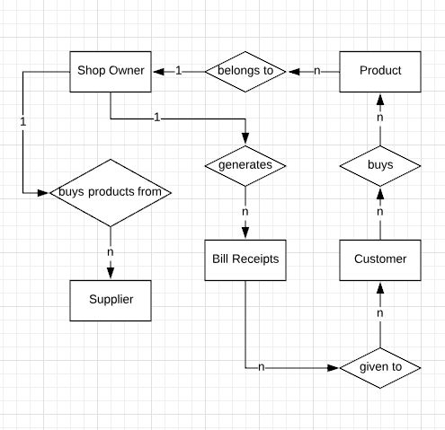

Simple E-R Diagram - Shop Management System

**B] DFD DIAGRAM :**

A data flow diagram (DFD) is a graphical representation of the "flow" of data through an information system, modeling its process aspects.

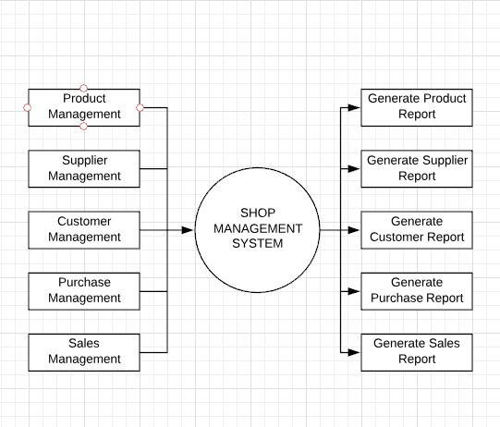

First Level DFD - Shop Management System

**DATA DICTIONARY**

A Data Dictionary is a set of information describing the contents, format, and structure of a database and the relationship between its elements, used to control access to and manipulation of the database.

A Data Dictionary is a catalog –a repository of the element in the system. The Data Dictionary stores details and description of data flows, data stores and processes. It provides additional information about the system. Thus, Data Dictionary is nothing but Data about Data.

**DATABASE TABLES :**

1. Table Name : Shop

Description : Contains information about Shop & Shop's Owner and Login information.

|  |  |
| --- | --- |
| **Field Name** | **Type** |
| ID | INTEGER |
| FIRSTNAME | TEXT |
| MIDDLENAME | TEXT |
| LASTNAME | TEXT |
| STREETADDRESS | TEXT |
| CITY | TEXT |
| STATE | TEXT |
| EMAIL | TEXT |
| PHONE | TEXT |
| MOBILE | INTEGER |
| BANKNAME | TEXT |
| BANKBRANCH | TEXT |
| BANKACNUMBER | INTEGER |
| BANKIFSC | TEXT |
| SHOPNAME | TEXT |
| GSTIN | TEXT |
| USERNAME | TEXT |
| PASSWORD | TEXT |

2. Table Name : Product

Description : Contains information about Products.

|  |  |
| --- | --- |
| **Field Name** | **Type** |
| PRODUCTID | INTEGER |
| PRODUCTNAME | TEXT |
| HSN | TEXT |
| MEASURINGUNIT | TEXT |
| GST | TEXT |
| PURCHASERATE | REAL |
| BASICPURCHASERATE | REAL |
| BASICSALERATE | REAL |
| SALERATE | REAL |
| SAFETYSTOCK | INTEGER |
| QUANTITY | INTEGER |

3. Table Name : Supplier

Description : Contains information about Suppliers.

|  |  |
| --- | --- |
| **Field Name** | **Type** |
| SUPPLIERID | INTEGER |
| SUPPLIERNAME | TEXT |
| MOBILE | INTEGER |
| STREETADDRESS | TEXT |
| CITY | TEXT |
| STATE | TEXT |
| GSTIN | TEXT |
| PAN | TEXT |
| SUPPLIERBALANCEPAYMENT | REAL |

4. Table Name : Customer

Description : Contains information about Customers.

|  |  |
| --- | --- |
| **Field Name** | **Type** |
| CUSTOMERID | INTEGER |
| CUSTOMERNAME | TEXT |
| MOBILE | INTEGER |
| STREETADDRESS | TEXT |
| CITY | TEXT |
| STATE | TEXT |
| GSTIN | TEXT |
| PAN | TEXT |
| CUSTOMERBALANCEPAYMENT | REAL |

5. Table Name : PurchaseTransaction

Description : Contains information about Purchase Transactions without Details.

|  |  |
| --- | --- |
| **Field Name** | **Type** |
| TID | INTEGER |
| BILLNO | TEXT |
| TDATE | TEXT |
| SUPPLIERID | INTEGER |
| TOTALAMOUNT | REAL |
| DISCOUNTP | REAL |
| DISCOUNTR | REAL |
| GRANDTOTAL | REAL |
| PAIDAMOUNT | REAL |

6. Table Name : PTDetails

Description : Contains information about Purchase Transactions Details.

|  |  |
| --- | --- |
| **Field Name** | **Type** |
| PTDID | INTEGER |
| BILLNO | TEXT |
| TDATE | TEXT |
| SUPPLIERID | INTEGER |
| PRODUCTID | INTEGER |
| QUANTITY | INTEGER |
| TAXABLEAMOUNT | REAL |
| CGSTP | REAL |
| CGSTA | REAL |
| SGSTP | REAL |
| SGSTA | REAL |
| TOTALAMOUNT | REAL |

7. Table Name : SaleTransaction

Description : Contains information about Sales Transactions without Details.

|  |  |
| --- | --- |
| **Field Name** | **Type** |
| TID | INTEGER |
| BILLNO | TEXT |
| TDATE | TEXT |
| CUSTOMERID | INTEGER |
| TOTALAMOUNT | REAL |
| DISCOUNTP | REAL |
| DISCOUNTR | REAL |
| GRANDTOTAL | REAL |
| PAIDAMOUNT | REAL |

8. Table Name : STDetails

Description : Contains information about Sales Transactions Details.

|  |  |
| --- | --- |
| **Field Name** | **Type** |
| STDID | INTEGER |
| BILLNO | TEXT |
| TDATE | TEXT |
| CUSTOMERID | INTEGER |
| PRODUCTID | INTEGER |
| QUANTITY | INTEGER |
| TAXABLEAMOUNT | REAL |
| CGSTP | REAL |
| CGSTA | REAL |
| SGSTP | REAL |
| SGSTA | REAL |
| TOTALAMOUNT | REAL |

9. Table Name : Theme

Description : Contains information about Themes.

|  |  |
| --- | --- |
| **Field Name** | **Type** |
| THEMEID | INTEGER |
| THEMENAME | TEXT |
| THEMEQUERY | TEXT |
| THEMESTATUS | TEXT |

**SCREENSHOTS**

1. ShopCreationForm1 :

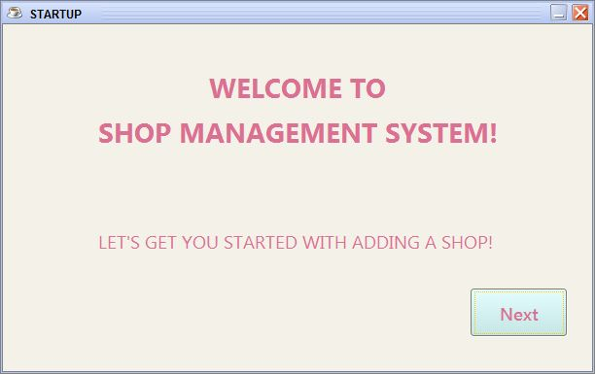

2. ShopCreationForm2 :

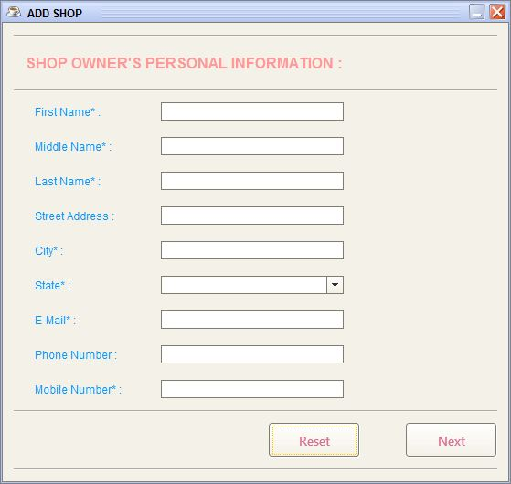

3. ShopCreationForm3 :

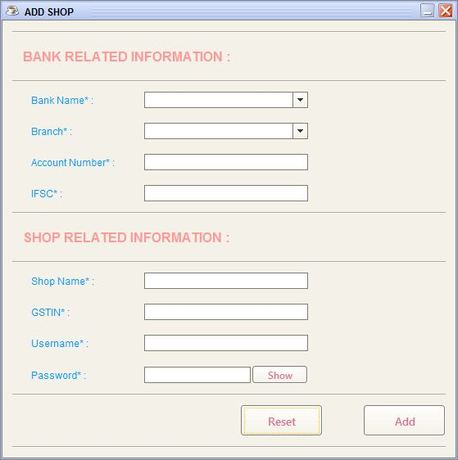

4. LoginForm :

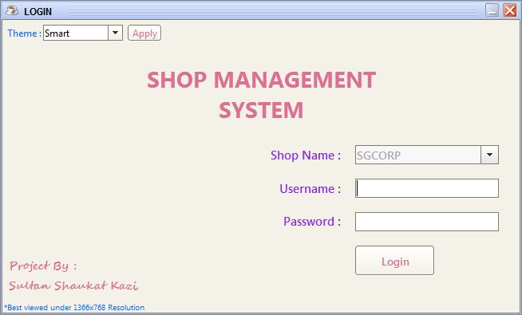

5. WelcomeForm :

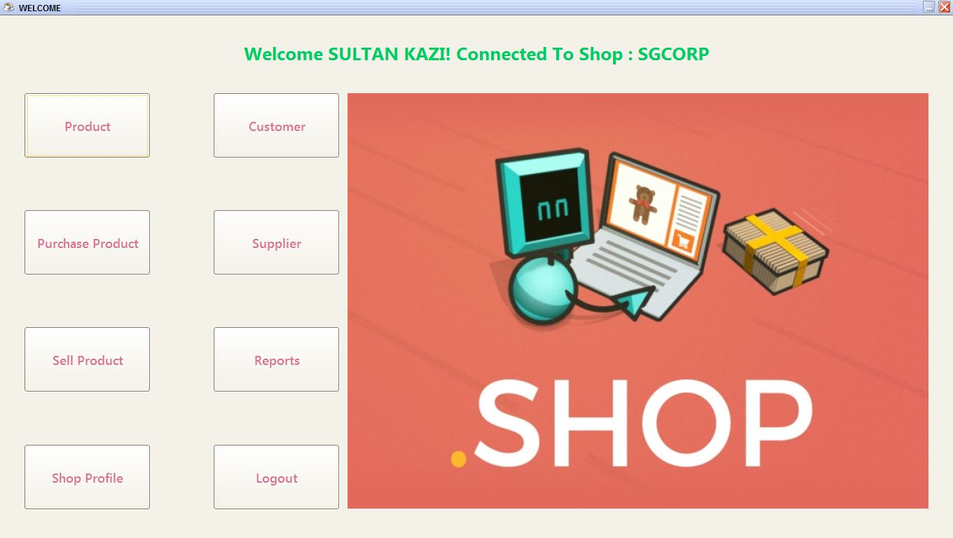

6. ProductForm :

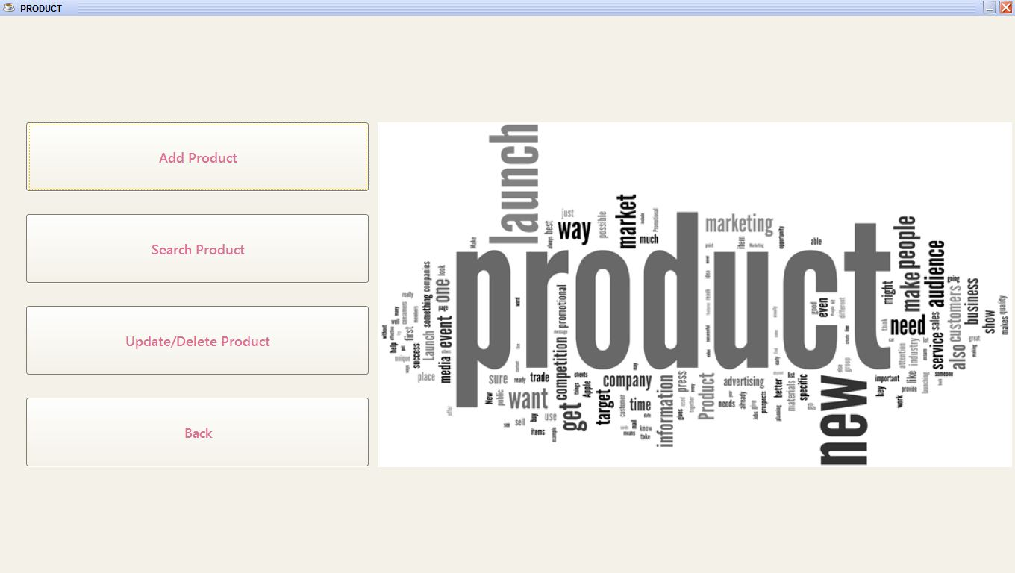

7. ProductAddForm :

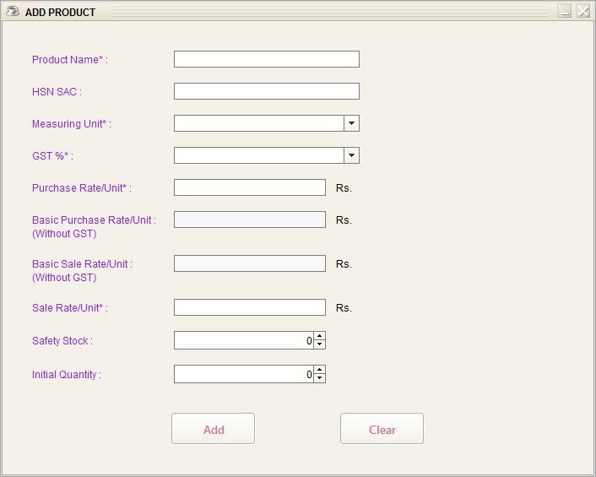

8. ProductSearchForm :

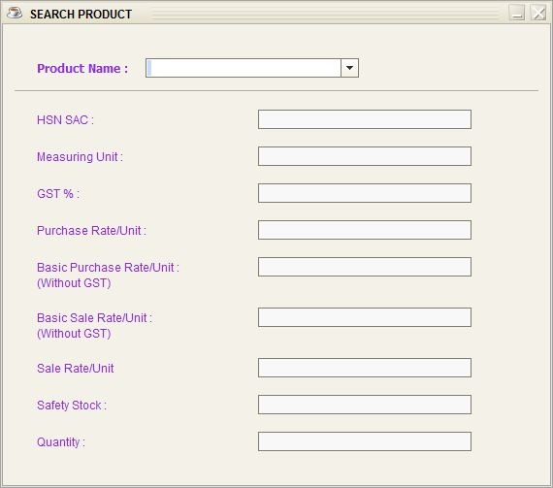

9. ProductUpdateDeleteForm :

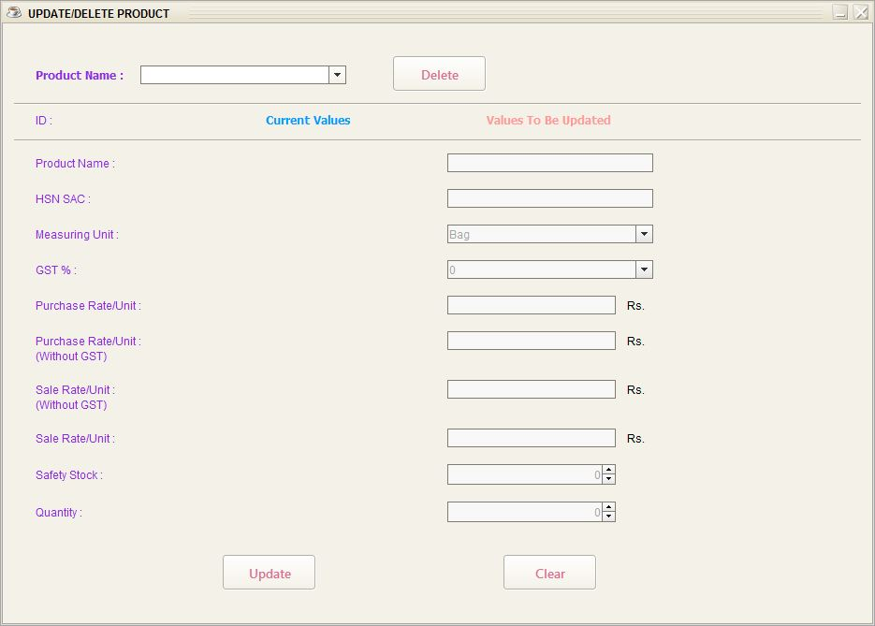

10. CustomerForm :

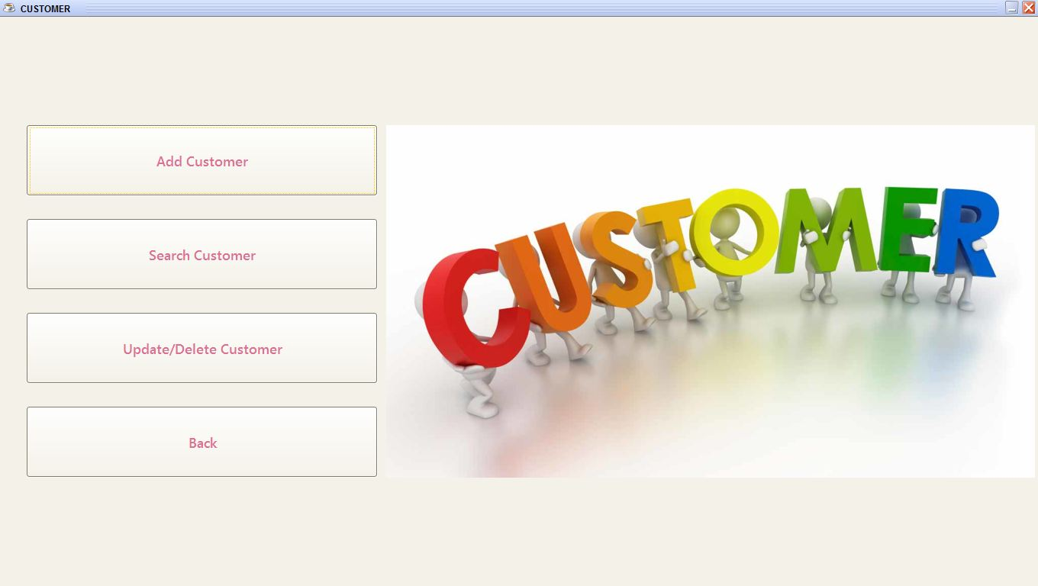

11. CustomerAddForm :

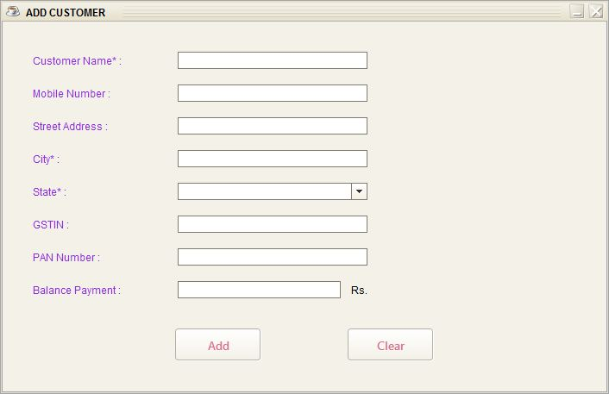

12. CustomerSearchForm :

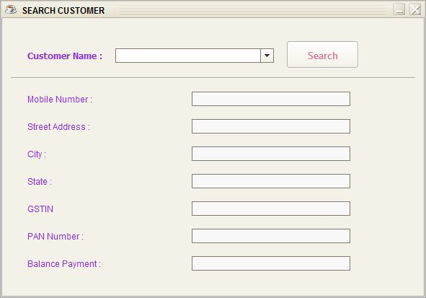

13. CustomerUpdateDeleteForm :

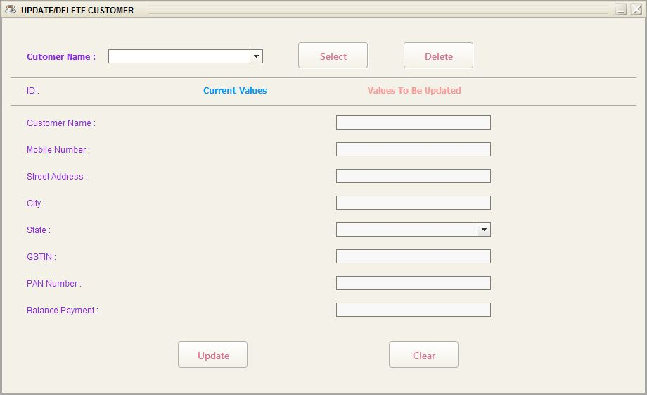

14. SupplierForm :

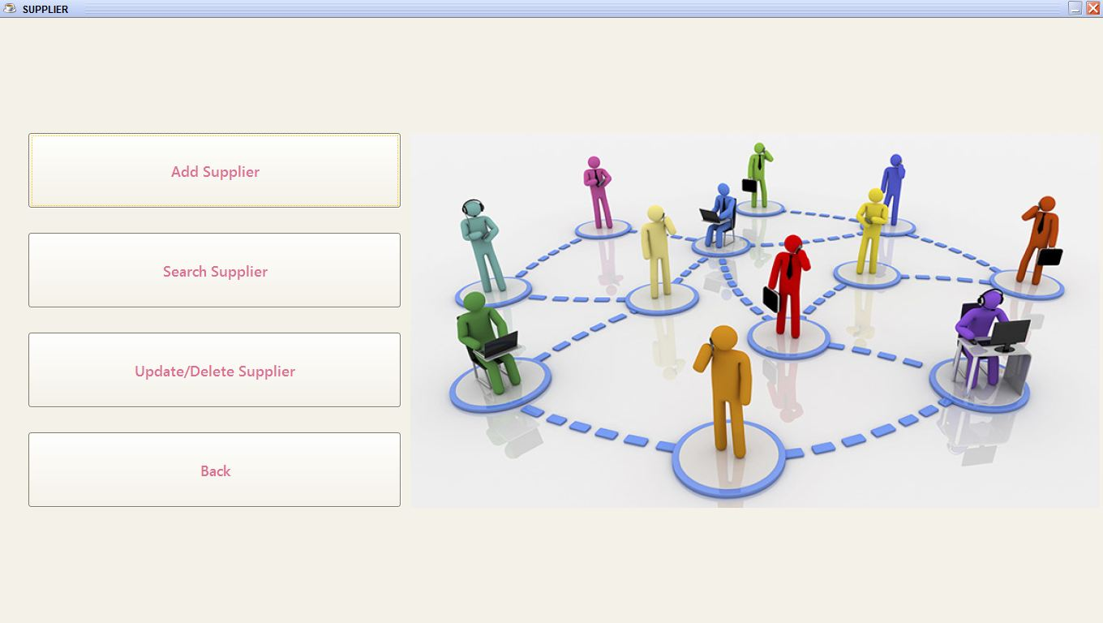

15. SupplierAddForm :

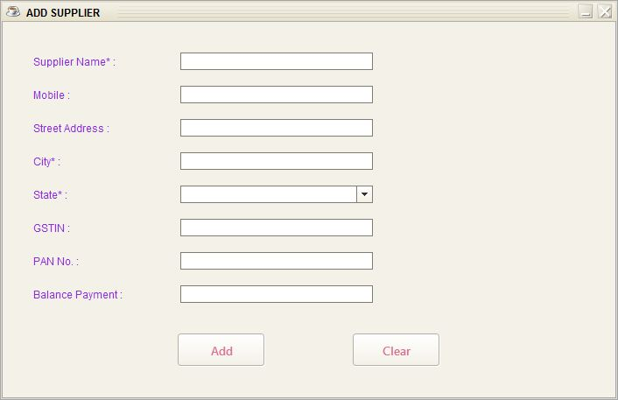

16. SupplierSearchForm :

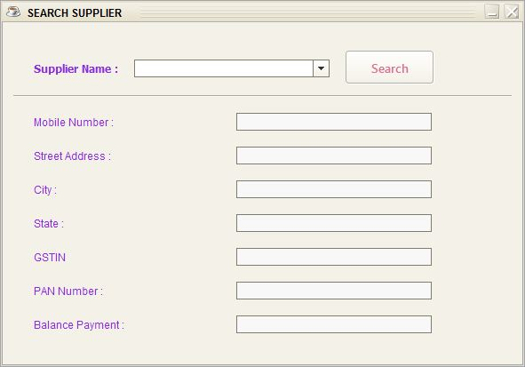

17. SupplierUpdateDeleteForm :

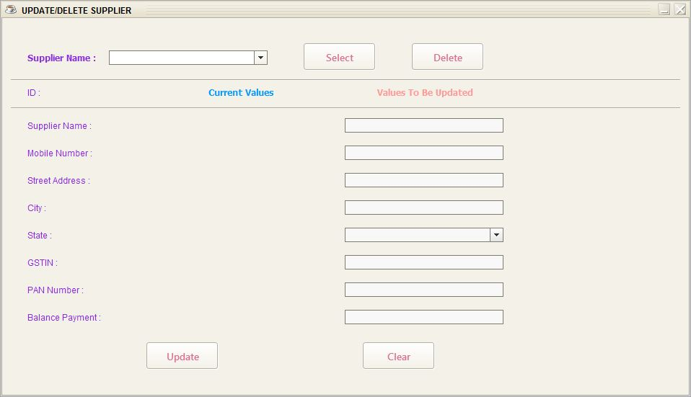

18. PurchaseProductForm :

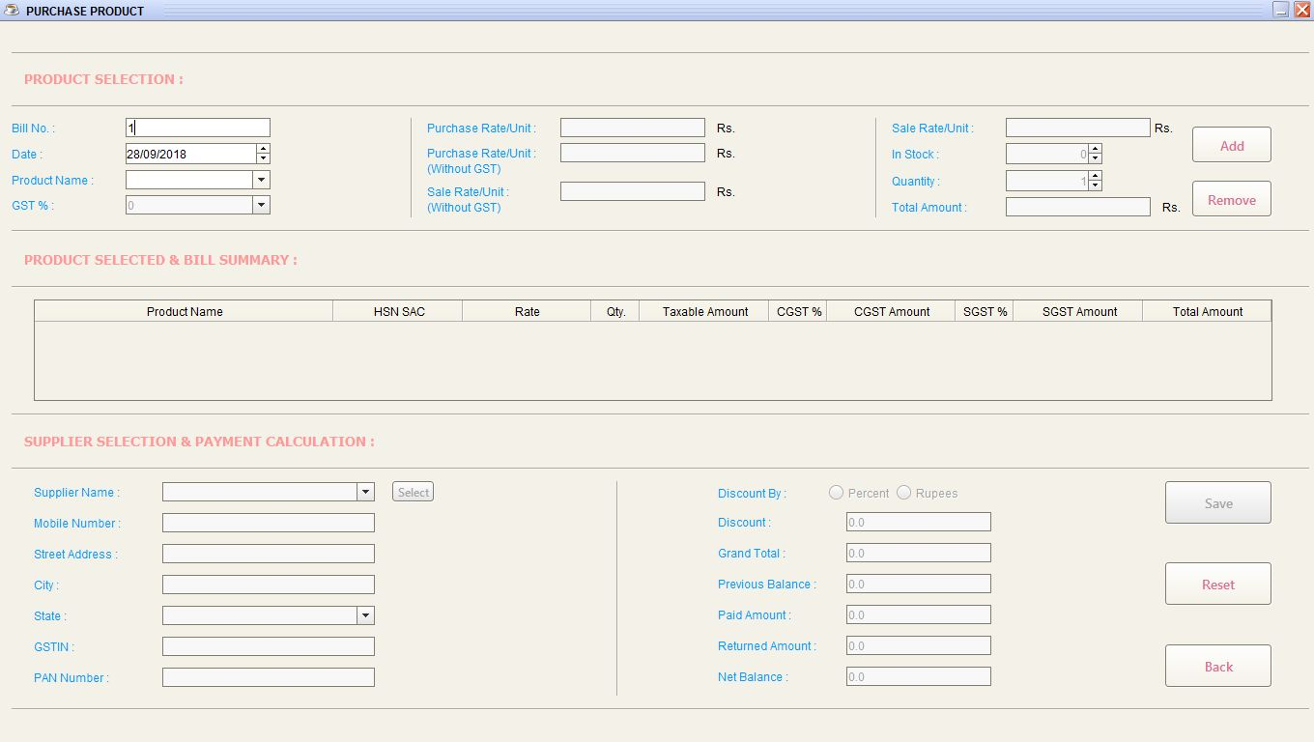

19. SellProductForm :

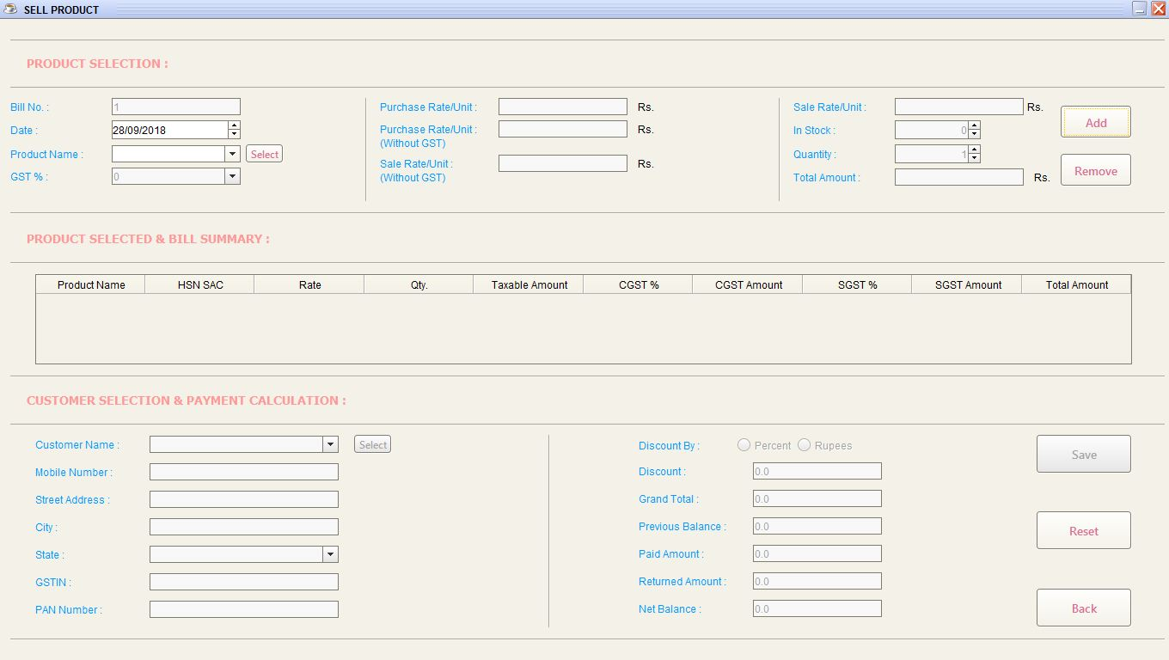

20. ReportsForm :

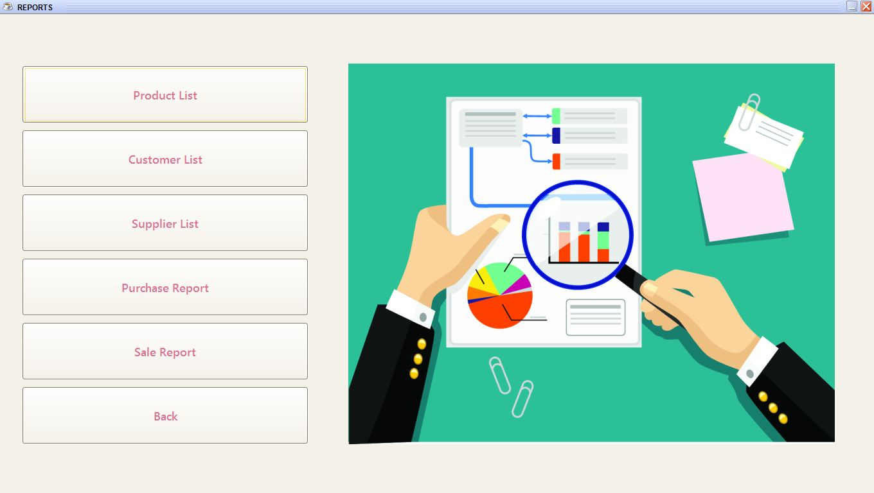

21. ProductListForm :

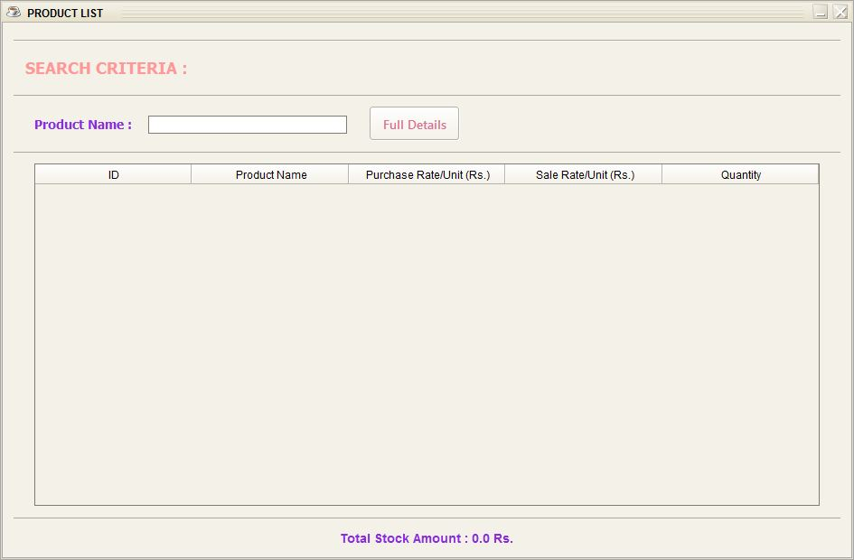

22. CustomerListForm :

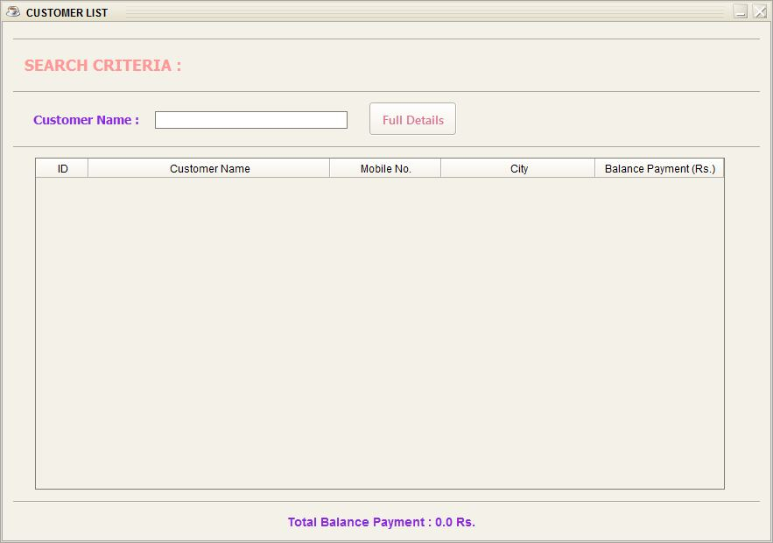

23. SupplierListForm :

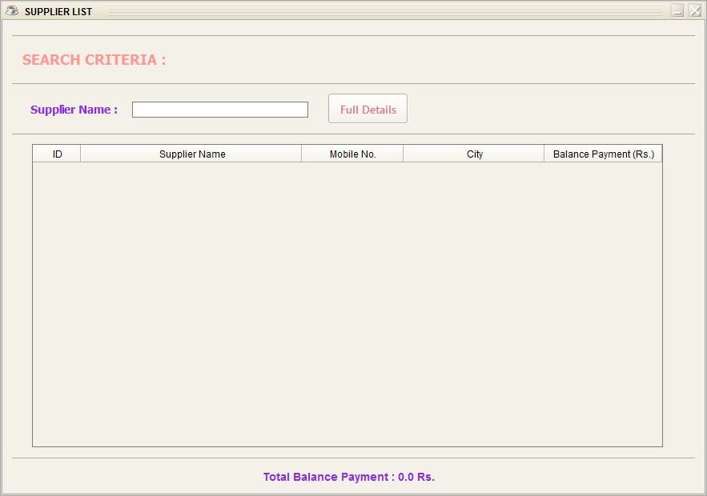

24. PurchaseReportForm :

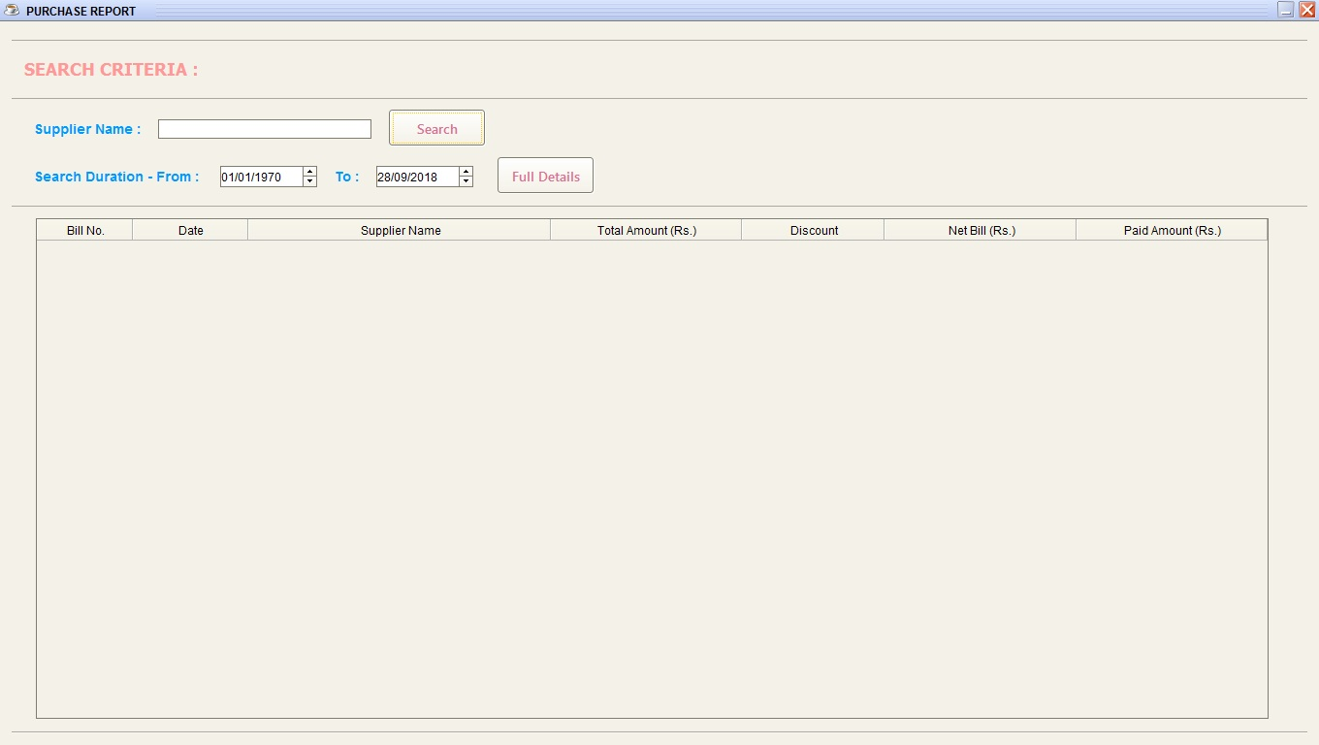

25. PurchaseDetails :

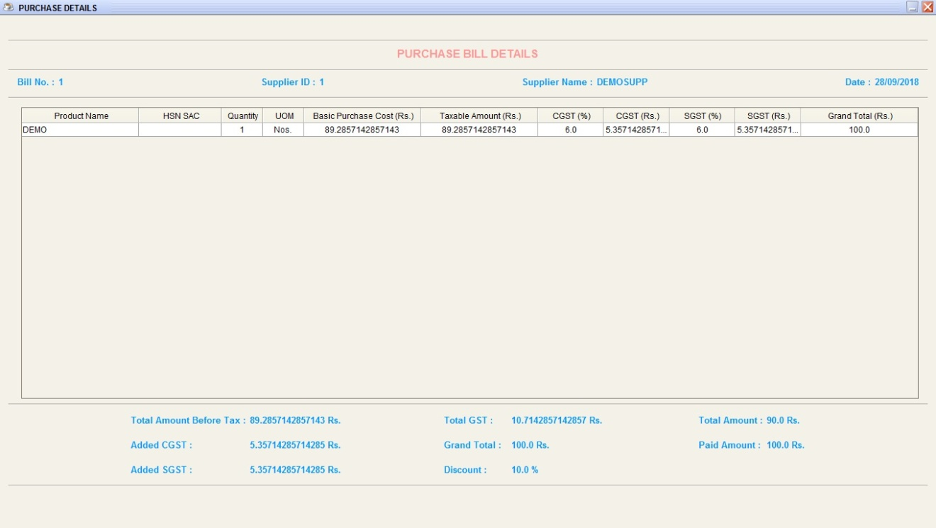

26. SaleReportForm :

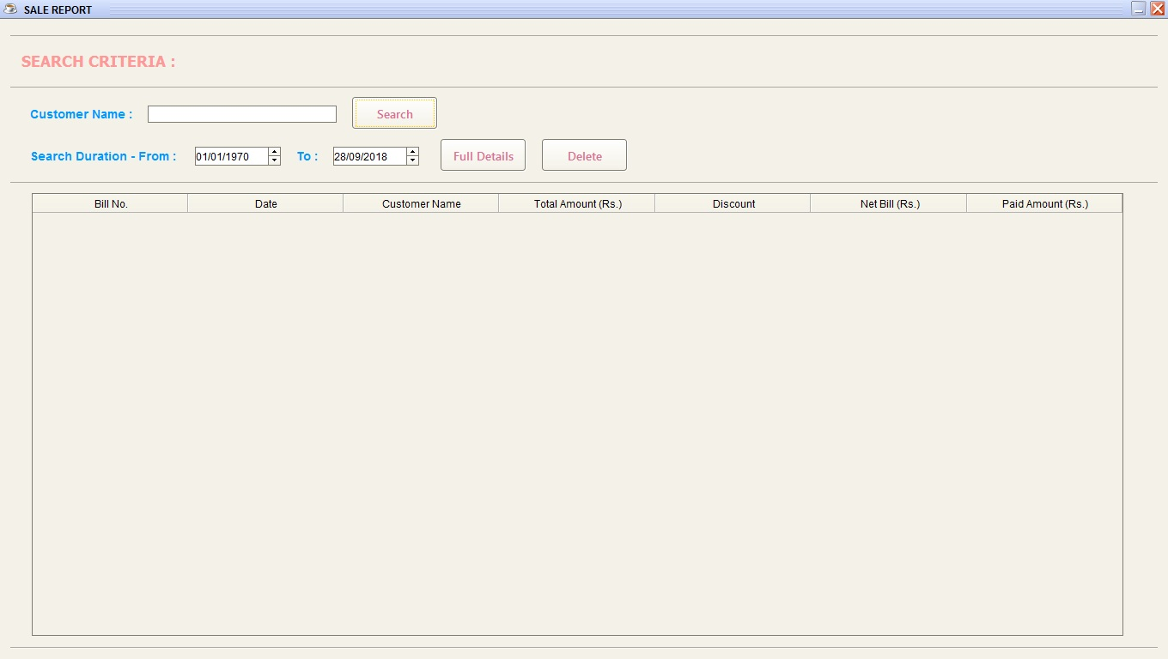

27. SaleDetails :

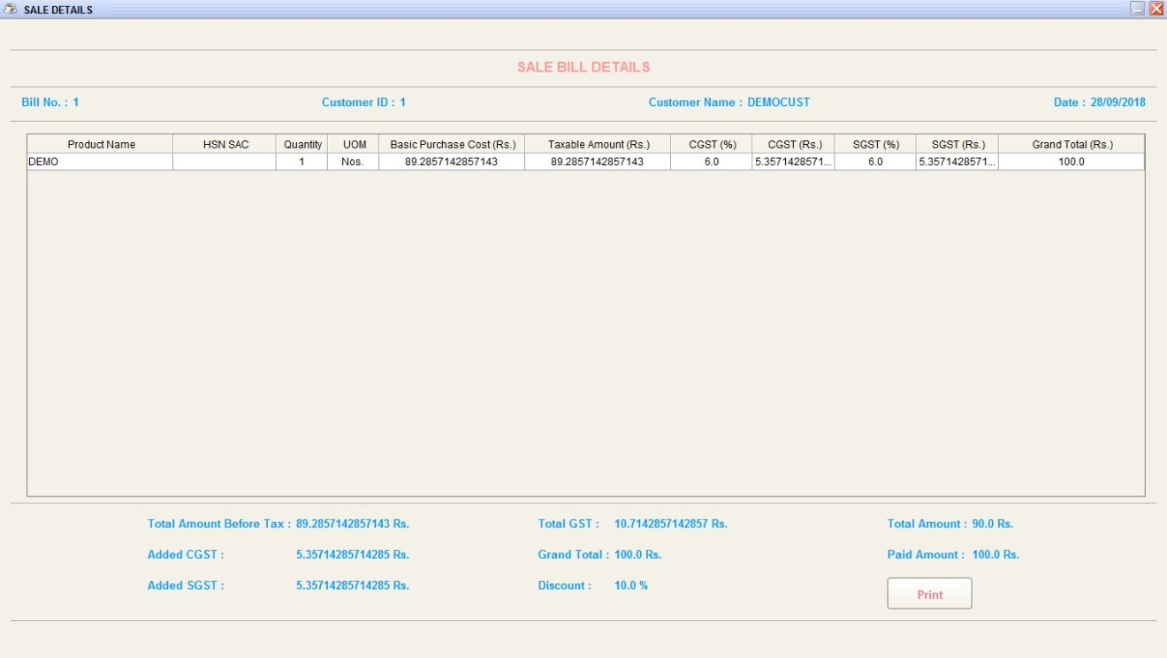

28. ShopProfileForm :

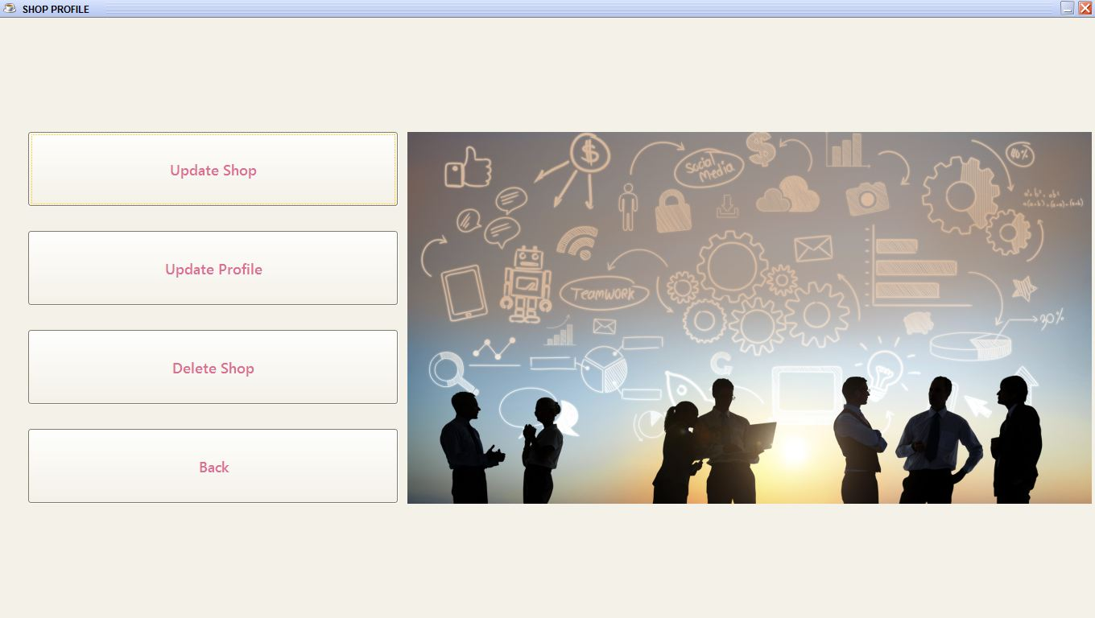

29. ShopUpdateForm :

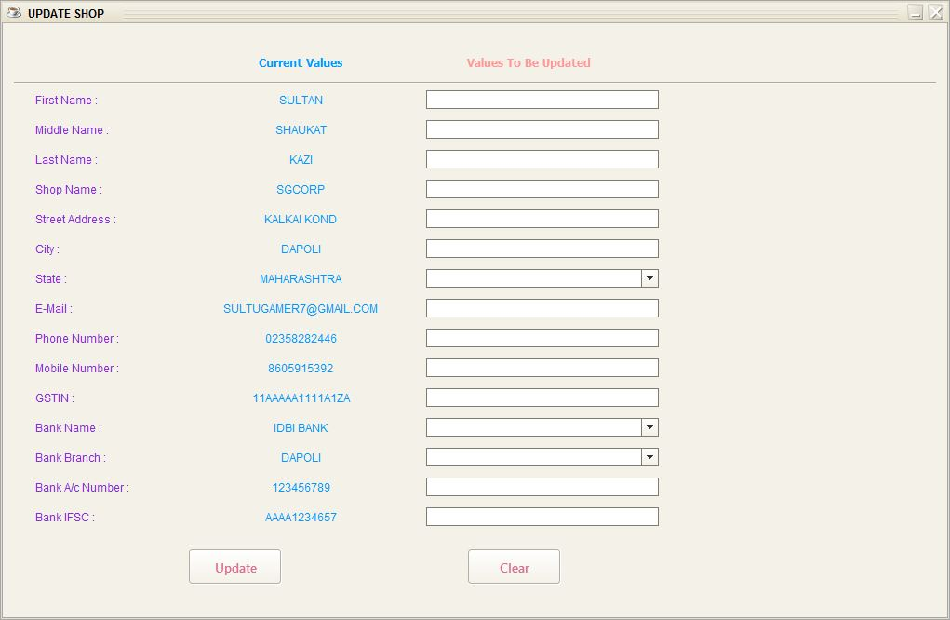

30. ShopProfileUpdateForm :

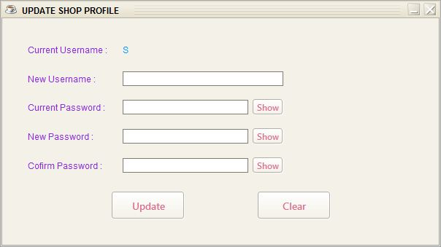

**CONCLUSION & FUTURE SCOPE**

The Shop Management System is developed using Java and SQLite. It fully meets the objectives of the system for which it has been developed. The system has reached a stable state where all the bugs have been removed. The system is also implemented and completely works as intended. It gives good results as per expectations and it also generates neat and clean bill prints for customers.

**Future Scope :**

* Cloud Backup.
* Multiple Shops Implementation.
* Multiple Product Selection.